**WEEK-1 HANDS-ON REPORT**

**KATTA GOUTHAMI MANOHARI**

**INTRODUCTION TO SERVICEOW**

ServiceNow is a flexible platform designed for digital transformation, allowing organizations to control and optimize operations without replacing present systems. The platform connects, automates, and streamlines approaches, improving efficiency, decreasing fees, and using boom.

BACKGROUND

Based in 2004, ServiceNow started out as a cloud-based answer geared toward simplifying paintings and improving commercial enterprise effects. through the years, the enterprise expanded its services to include a wide range of offerings such because its carrier control, customer service, human sources, and safety operations.

THE NOW PLATFORM

On the heart of ServiceNow’s offerings is the Now Platform. This AI-powered, low-code platform permits agencies to adapt speedy to modifications, automate workflows, and improve the consumer enjoy. It integrates seamlessly with existing systems, assisting corporations maximize their technology investments.

ENTERPRISE PROGRAMS

ServiceNow serves a numerous array of industries:

* Training: Automates processes like course registration and IT assist.
* Healthcare: complements affected person care through streamlining admissions, bed control, and device renovation.
* Monetary offerings: Improves patron reports and operational efficiency even as ensuring regulatory compliance.
* Government: complements service delivery, transparency, and operational efficiency.
* Retail: Manages inventory, supply chain operations, and patron reports each on-line and in-shop.

ENTERPRISE BENEFITS

ServiceNow’s solutions empower organizations to:

* Reduce fees: Streamline operations and optimize aid use.
* Pressure increase: enhance performance and scalability.
* Beautify client experience: offer better service thru automation and AI-pushed insights.
* Keep Agility: speedy adapt to adjustments with low-code improvement and seamless integration.

**SERVICENOW PLATFORM OVERVIEWS:**

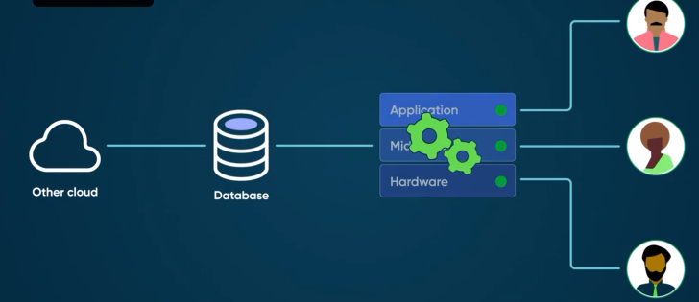

ADMINISTRATION:

The Now Platform Admin middle offers smooth subscription management, a comprehensive service catalog, and complete control over workflow optimization. It supports localization in more than one languages and affords strong analytics for person activity and protection.

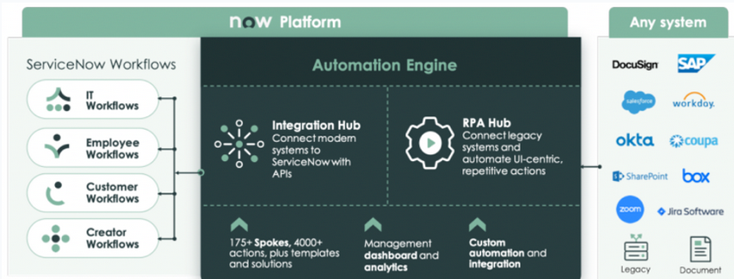

INTEGRATION:

The Automation Engine at the Now Platform enables seamless integration with external offerings, supporting each unidirectional and bidirectional records flows. It uses the MID Server device for connection and automation, with pre-built techniques for numerous responsibilities and 1/3-birthday celebration offerings.

**SERVICENOW USER INTERFACE OVERVIEW:**

The ServiceNow user interface gives large customization options, allowing administrators to alter CSS and machine properties to modify the platform's appearance, which include logos and banners, without affecting it's functionality. Navigation is streamlined with features like the **Navigation Stack** for guiding users and **Navigation action Cancellation** for quick changes in route, even as **consumer preferences** permit individuals to tailor UI elements together with row displays and response time indicators. The platform additionally helps **Context-touchy assist** for relevant assets and **review help Pages** for new features, alongside sturdy accessibility options like **Keyboard Navigation** and display reader guide. Multimedia control is improved with the potential to store and control **Audio files** and **pics** in the database. additionally, users can personalize views for bureaucracy and lists, and **Welcome Pages** offer vital facts upon login. superior tools, inclusive of **Map Pages** for graphical information display and **reaction Time signs** for tracking overall performance, similarly enrich the person experience.

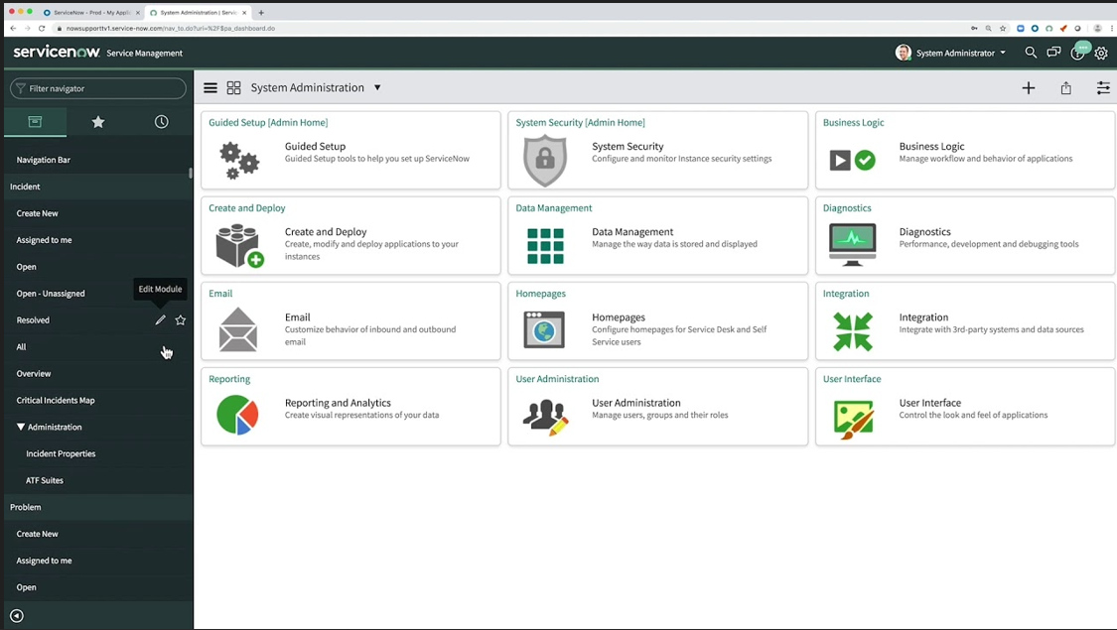

**SERVICENOW BRANDING:**

ServiceNow branding allows groups to tailor the platform’s look and sense to suit their identification. This customization is facilitated via tools like **organization Guided Setup** for aligning the interface with branding recommendations, the **ServiceNow Portal** for creating a customized person-facing portal, and the **UI Builder** for designing and editing user interfaces inside the platform. those features make sure that the ServiceNow surroundings reflects the specific branding of the business enterprise.

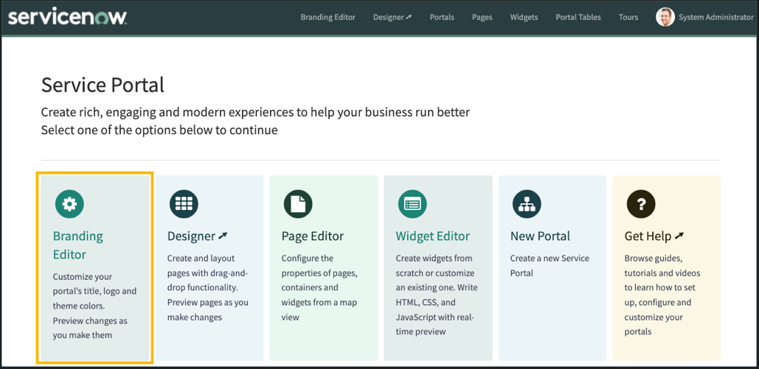

**SERVICENOW LISTS AND FILTERS**

ServiceNow Lists and Filters provide robust gear for effective statistics control in the platform.

* The list View Interface enables customers to prepare, sort, and show records successfully, making it less difficult to navigate massive datasets.
* Manage Data functions allow for customization of ways facts are offered, whether with the aid of sorting columns, grouping information, or adjusting seen fields.
* Apply Filters we could users set specific situations to slender down records, permitting them to recognition on relevant statistics fast. This helps in pinpointing vital records with out wading via needless information.
* Moreover, List Controls provide options to control the display and interplay with lists, which includes fresh statistics, personalizing the format, and setting default views. those tools collectively enhance the consumer's ability to control and have interaction with records in a streamlined, intuitive way.

**FORMS IN SERVICENOW**

ServiceNow forms are a core feature of the platform, providing a structured way to collect, display, and manage data. They consist of various field types, can be customized in layout and functionality, and support features like UI policies and client scripts. Forms are used for data entry, displaying information, and enabling users to update records. They can be integrated with workflows, embedded in service portals, and accessed on mobile devices. ServiceNow forms play a crucial role in streamlining business processes, improving data accuracy, and enhancing user experience across the platform.

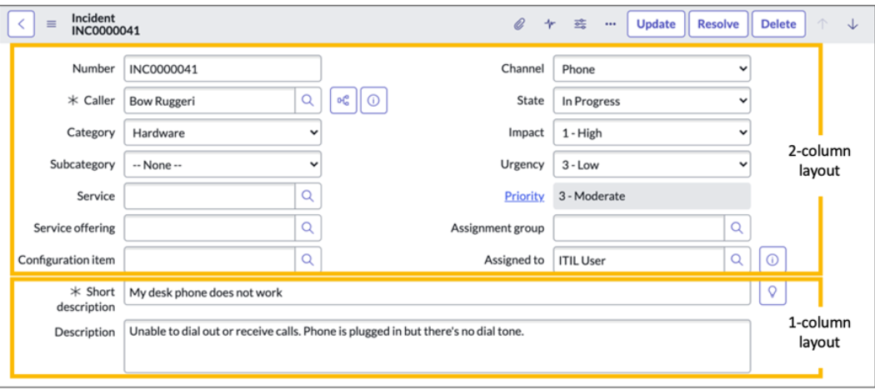

**SERVICENOW TOOLS DEMO:**

The Hands-on Tool Demo gave me practical experience with the ServiceNow platform, including:

* Navigation: Using the Next Experience UI to navigate the platform and access applications.
* Lists and Forms: Managing records and using list and form views within the ServiceNow database.
* Knowledge Management: Understanding the management and access of knowledge articles.
* ServiceNow Instances: Working with Production, Testing, and Development instances.

**IMPORTING DATA IN SERVICENOW**

The key steps to import data into ServiceNow:

* Prepare data: Organize in spreadsheet format with matching column headers.
* Choose method: Select Transform Maps or Import Sets based on complexity.
* Upload file: Use "System Import Sets" > "Load Data" to upload your file.
* Create/select Transform Map: Map source columns to target fields.
* Run import: Execute the Transform Map or Import Set.
* Check target table and validate imported data.

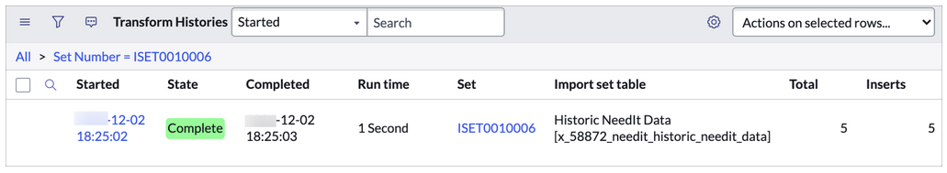

**INCIDENT MANAGEMENT AND TASK ADMINISTRATION:**

Overview of Incident Management in ServiceNow, focusing on key components:

* Incident Management:
* Lifecycle Management: Manages the entire lifecycle of incidents from detection to resolution.
* Incident States:
  + - New
    - In Progress
    - On Hold
    - Resolved
    - Closed
* Ticket Creation:
* Task Records: Documentation and tracking of tasks related to incidents.
* Task Lifecycle:
  + Open
  + Work in Progress
  + Closed
* Task Assignment:
* Groups
* Individuals
* Notifications: Alerts and customizable notifications for task updates and resolutions.